

Department of Computer Science and Engineering

(Artificial Intelligence and Machine Learning)
School of Computing

ACADEMIC YEAR 2025 – 2026
Winter Semester

10212CA215: Deep Learning

LAB MANUAL



School of Computing

Department of Computer Science and Engineering

(Artificial Intelligence and Machine Learning)

10212CA215: Deep Learning

ACADEMIC YEAR 2025 – 2026
Winter Semester

INDEX

S.No. | Particulars | Page No.
1 | Syllabus
2 | Task Plan
3 | Implementation of a Multiclass classification model for grey-scale image
4 | Implementation of a Convolutional Neural Network (CNN) classification model
5 | Construct a Convnet model for image classification
6 | Application of Transfer Learning to build an image classification model
7 | Implement a simple Generative Adversarial Network (GAN
8 | Implementation of word embedding using RNN
9 | Implementation of Auto encoders
10 | Implementation of prediction using LSTM networks
11 | Implementation of object detection and localization
12 | Apply optimization techniques to improve model performance
13 | Use Case:

TASK 1

IMPLEMENTATION OF MULTICLASS CLASSIFICATION FOR GRAY SCALE IMAGES

Aim:

To use tensorflow for implementation of multiclass classification for gray scale image. Procedure:
Step 1: import the required libraries Step 2: load & preprocess the dataset Step 3: define the model architecture Step 4: compile the model
Step 5: train the model

Step 6: evaluate the model using test data

Step 7: using visualization techniques for determining the performance metrics

Program
import tensorflow as tf
from tensorflow.keras import datasets
from tensorflow.keras.models import Sequential from tensorflow.keras import layers
from tensorflow.keras import models, layers
(train_images, train_labels), (test_images, test_labels) = datasets.cifar10.load_data() train_images, test_images = train_images / 255.0, test_images / 255.0
class_names = ['airplane', 'automobile', 'bird', 'cat', 'deer', 'dog', 'frog', 'horse', 'ship', 'truck']
model = models.Sequential()
model.add(layers.Conv2D(32, (3, 3), activation='relu', input_shape=(32, 32, 3)))
model.add(layers.MaxPooling2D((2, 2)))
model.add(layers.Conv2D(64, (3, 3), activation='relu'))
model.add(layers.MaxPooling2D((2, 2)))
model.add(layers.Conv2D(64, (3, 3), activation='relu')) model.add(layers.Flatten()) model.add(layers.Dense(64, activation='relu')) model.add(layers.Dense(10)) model.compile(optimizer='adam', loss=tf.keras.losses.SparseCategoricalCrossentropy(from_logits=True),

metrics=['accuracy'])
history = model.fit(train_images, train_labels, epochs=10, validation_data=(test_images, test_labels))
import matplotlib.pyplot as plt plt.figure(figsize=(8, 8)) plt.plot(history.history['accuracy'], label='accuracy')
plt.plot(history.history['val_accuracy'], label = 'val_accuracy') plt.xlabel('Epoch')
plt.ylabel('Accuracy') plt.ylim([0.5, 1]) plt.legend(loc='lower right') plt.savefig("output_report.png")

OUTPUT:
Epoch 1/10
1563/1563 [==============================] - 80s 50ms/step - loss: 1.5129 - accuracy:
0.4485 - val_loss: 1.2795 - val_accuracy: 0.5465 Epoch 2/10
1563/1563 [==============================] - 76s 49ms/step - loss: 1.1397 - accuracy:
0.5965 - val_loss: 1.0586 - val_accuracy: 0.6189 Epoch 3/10
1563/1563 [==============================] - 75s 48ms/step - loss: 0.9859 - accuracy:
0.6548 - val_loss: 0.9609 - val_accuracy: 0.6641 Epoch 4/10
1563/1563 [==============================] - 78s 50ms/step - loss: 0.8883 - accuracy:
0.6898 - val_loss: 0.9351 - val_accuracy: 0.6731 Epoch 5/10
1563/1563 [==============================] - 76s 49ms/step - loss: 0.8145 - accuracy:
0.7147 - val_loss: 0.8953 - val_accuracy: 0.6889 Epoch 6/10
1563/1563 [==============================] - 76s 49ms/step - loss: 0.7576 - accuracy:
0.7353 - val_loss: 0.8864 - val_accuracy: 0.6949 Epoch 7/10
1563/1563 [==============================] - 76s 49ms/step - loss: 0.7055 - accuracy:
0.7533 - val_loss: 0.8584 - val_accuracy: 0.7112 Epoch 8/10
1563/1563 [==============================] - 75s 48ms/step - loss: 0.6600 - accuracy:
0.7691 - val_loss: 0.9043 - val_accuracy: 0.6992 Epoch 9/10

1563/1563 [==============================] - 75s 48ms/step - loss: 0.6200 - accuracy:
0.7819 - val_loss: 0.8517 - val_accuracy: 0.7128 Epoch 10/10
1563/1563 [==============================] - 73s 47ms/step - loss: 0.5821 - accuracy:
0.7948 - val_loss: 0.9044 - val_accuracy: 0.7027 [ ]
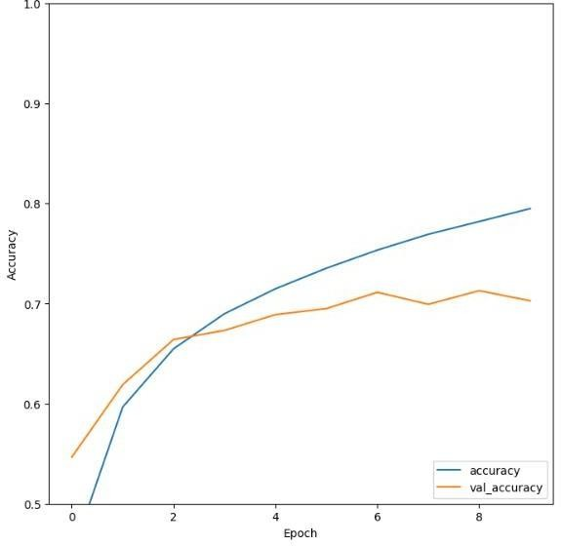

Result:
Thus the Implementation of multiclass classification for gray scale image is successfully completed.

TASK 2

IMPLEMENTATION OF A CONVOLUTIONAL NEURAL NETWORK CLASSIFICATION MODEL USING TENSORFLOW
Aim:

To implement convolutional neural network using tensor flow

Procedure:

Step 1: Import the required libraries Step 2: Load the preprocess dataset Step 3: Define the model architecture Step 4: Compile & train the model
Step 5: Evaluate the model using test data

Step 6: Using visualization techniques for determining the performance metrics

Program:
from tensorflow.keras.datasets import mnist from tensorflow.keras.models import Sequential from tensorflow.keras.layers import Conv2D from tensorflow.keras.layers import MaxPool2D from tensorflow.keras.layers import Flatten from tensorflow.keras.layers
import Dropout from tensorflow.keras.layers import Dense (X_train,y_train) , (X_test,y_test)=mnist.load_data()
X_train = X_train.reshape((X_train.shape[0], X_train.shape[1], X_train.shape[2], 1)) X_test = X_test.reshape((X_test.shape[0],X_test.shape[1],X_test.shape[2],1)) print(X_train.shape)
print(X_test.shape) X_train=X_train/255 X_test=X_test/255 model=Sequential()
model.add(Conv2D(32,(3,3),activation='relu',input_shape=(28,28,1))) model.add(MaxPool2D(2,2))
model.add(Flatten()) model.add(Dense(100,activation='relu')) model.add(Dense(10,activation='softmax'))
model.compile(loss='sparse_categorical_crossentropy',optimizer='adam',metrics=['accuracy']) model.fit(X_train,y_train,epochs=10)
model.evaluate(X_test,y_test)

OUTPUT:
Epoch 1/10
1875/1875 [==============================] - 43s 23ms/step - loss: 0.1620 - accuracy:
0.9506
Epoch 2/10
1875/1875 [==============================] - 43s 23ms/step - loss: 0.0565 - accuracy:
0.9823
Epoch 3/10
1875/1875 [==============================] - 41s 22ms/step - loss: 0.0374 - accuracy:

0.9883
Epoch 4/10
1875/1875 [==============================] - 41s 22ms/step - loss: 0.0249 - accuracy:
0.9923
Epoch 5/10
1875/1875 [==============================] - 41s 22ms/step - loss: 0.0169 - accuracy:
0.9947
Epoch 6/10
1875/1875 [==============================] - 41s 22ms/step - loss: 0.0133 - accuracy:
0.9957
Epoch 7/10
1875/1875 [==============================] - 42s 22ms/step - loss: 0.0090 - accuracy:
0.9972
Epoch 8/10
1875/1875 [==============================] - 42s 23ms/step - loss: 0.0074 - accuracy:
0.9977
Epoch 9/10
1875/1875 [==============================] - 40s 21ms/step - loss: 0.0055 - accuracy:
0.9982
Epoch 10/10
1875/1875 [==============================] - 40s 21ms/step - loss: 0.0052 - accuracy:
0.9983 [ ]

Result:
Thus the Implementing convolutional neural network using tensor flow is successfully completed.
TASK 3

ALEXNET FROM SCRATCH IN TENSORFLOW . PY

Aim:

To create alexnet from scratch in tensorflow.py Procedure:
Step 1: Import the necessary libraries

Step 2: Define the alexnet architecture as a function Step 3: Define the input shape & number of classes Step 4: Create an instance of alexnet
Step 5: Print the model summary

Program :
import tensorflow_datasets as tfds (train_dataset, test_dataset), info = tfds.load(
'cats_vs_dogs',
split = ('train[:80%]', 'train[80%:]'), with_info = True, as_supervised=True)
len(train_dataset), len(test_dataset) for X, y in train_dataset:
print(X.shape, y.numpy()) image_1 = X.numpy() break
import matplotlib.pyplot as plt plt.imshow(image_1)
import tensorflow as tf
def normalize_img(image, label):
return (tf.cast(image, tf.float32) / 255.0, label) def resize(image, label):
return (tf.image.resize(image, (224, 224)), label)
train_dataset = train_dataset.map(resize, num_parallel_calls=tf.data.AUTOTUNE) train_dataset = train_dataset.map(normalize_img, num_parallel_calls=tf.data.AUTOTUNE) SHUFFLE_VAL = len(train_dataset) // 1000 # Divide by big value on free Colab BATCH_SIZE = 4 # Use small batch size on free Colab
train_dataset = train_dataset.shuffle(SHUFFLE_VAL) train_dataset = train_dataset.batch(BATCH_SIZE) train_dataset = train_dataset.prefetch(tf.data.AUTOTUNE)
test_dataset = test_dataset.map(resize, num_parallel_calls=tf.data.AUTOTUNE) test_dataset = test_dataset.map(normalize_img, num_parallel_calls=tf.data.AUTOTUNE) test_dataset = test_dataset.batch(BATCH_SIZE)
test_dataset = test_dataset.prefetch(tf.data.AUTOTUNE) for (img, label) in train_dataset: print(img.numpy().shape, label.numpy()
break
from tensorflow.keras import layers
from tensorflow.keras.models import Model

def AlexNet():
inp = layers.Input((224, 224, 3))
x = layers.Conv2D(96, 11, 4, activation='relu')(inp) x = layers.BatchNormalization()(x)
x = layers.MaxPooling2D(3, 2)(x)
x = layers.Conv2D(256, 5, 1, activation='relu')(x) x = layers.BatchNormalization()(x)
x = layers.MaxPooling2D(3, 2)(x)
x = layers.Conv2D(384, 3, 1, activation='relu')(x)
x = layers.Conv2D(384, 3, 1, activation='relu')(x)
x = layers.Conv2D(256, 3, 1, activation='relu')(x) x = layers.MaxPooling2D(3, 2)(x)
x = layers.Flatten()(x)
x = layers.Dense(4096, activation='relu')(x) x = layers.Dropout(0.5)(x)
x = layers.Dense(4096, activation='relu')(x) x = layers.Dropout(0.5)(x)
x = layers.Dense(1, activation='sigmoid')(x) model = Model(inputs=inp, outputs=x) return model
model = AlexNet() model.summary() tf.keras.utils.plot_model(
model, to_file='model.png', show_shapes=True, show_dtype=False, show_layer_names=False,
show_layer_activations=True, dpi=100
)

for (img, label) in train_dataset: print(model(img).numpy().shape, label.numpy()) break
from tensorflow.keras.optimizers import Adam

from tensorflow.keras.losses import BinaryCrossentropy model.compile(loss=BinaryCrossentropy(),
optimizer=Adam(learning_rate=0.001), metrics=['accuracy']) from tensorflow.keras.callbacks import EarlyStopping
es = EarlyStopping(patience=5,
monitor='loss')
model.fit(train_dataset, epochs=10, validation_data=test_dataset, callbacks=[es])

OUTPUT:
Epoch 1/10
4653/4653 [==============================] - 2197s 472ms/step - loss: 0.7012 - accuracy:
0.5031 - val_loss: 0.6931 - val_accuracy: 0.5099 Epoch 2/10
4653/4653 [==============================] - 2128s 457ms/step - loss: 0.6934 - accuracy:
0.4988 - val_loss: 0.6933 - val_accuracy: 0.4901 Epoch 3/10
4653/4653 [==============================] - 2112s 454ms/step - loss: 0.7023 - accuracy:
0.5008 - val_loss: 0.6936 - val_accuracy: 0.5099 Epoch 4/10
4653/4653 [==============================] - 2148s 462ms/step - loss: 0.6939 - accuracy:
0.5039 - val_loss: 0.6930 - val_accuracy: 0.5099 Epoch 5/10
4653/4653 [==============================] - 2141s 460ms/step - loss: 0.6934 - accuracy:
0.5008 - val_loss: 0.6932 - val_accuracy: 0.4901 Epoch 6/10
4653/4653 [==============================] -
2146s 461ms/step - loss: 0.6935 - accuracy:
0.5002 - val_loss: 0.6933 - val_accuracy: 0.4901 Epoch 7/10
4653/4653 [==============================] - 2169s 466ms/step - loss: 0.6933 - accuracy:
0.5021 - val_loss: 0.6933 - val_accuracy: 0.4901 Epoch 8/10
4653/4653 [==============================] - 2143s 461ms/step - loss: 0.6933 - accuracy:
0.5001 - val_loss: 0.6934 - val_accuracy: 0.4901 Epoch 9/10
4653/4653 [==============================] - 2133s 458ms/step - loss: 0.6932 - accuracy:
0.5030 - val_loss: 0.6933 - val_accuracy: 0.4901

Epoch 10/10
4653/4653 [==============================] - 2126s 457ms/step - loss: 0.6932 - accuracy:
0.5029 - val_loss: 0.6933 - val_accuracy: 0.4901

Result:
Thus, the Creating alexnet from scratch in tensorflow is successfully completed.

TASK 4

VGG16 PRETRAINED MODEL

Aim:

To create vgg16 pretrained model from transfer learning. Procedure:
Step 1: Import the necessary libraries. Step 2: Define different layers using keras Step 3: Define the path of dataset
Step 4: Display output of dataset in a given path Step 5: Define function as vgg16( )
Step 6: Print model summary

Program:
#pytefrom google.colab import drive #drive.mount('/content/drive')
from google.colab import drive drive.mount('/content/drive') import cv2
import numpy as np import os
from keras.preprocessing.image import ImageDataGenerator
from keras.layers import Dense,Flatten,Conv2D,Activation,Dropout from keras import backend as K

import keras
from keras.models import Sequential, Model from keras.models import load_model #from keras.optimizers import SGD
from keras.callbacks import EarlyStopping,ModelCheckpoint from keras.layers import MaxPool2D
from google.colab.patches import cv2_imshow from tensorflow.python.client import device_lib print(device_lib.list_local_devices()) #K.tensorflow_backend._get_available_gpus() import keras.backend as K train_path="/content/drive/MyDrive/archive/train" test_path="/content/drive/MyDrive/archive/test" class_names=os.listdir(train_path) class_names_test=os.listdir(test_path) print(class_names)
print(class_names_test) #Sample datasets images
image_criminal=cv2.imread("/content/drive/MyDrive/archive/test/ALTAMIRA YELLOWTHROAT/1.jpg")
cv2_imshow(image_criminal) image_normal=cv2.imread("/content/drive/MyDrive/archive/test/AMERICAN AVOCET/1.jpg")
cv2_imshow(image_normal) image_Suspicious=cv2.imread("/content/drive/MyDrive/archive/test/AMERICAN BITTERN/2.jpg") cv2_imshow(image_Suspicious)
train_datagen = ImageDataGenerator(zoom_range=0.15,width_shift_range=0.2,height_shift_range=0.2,shear_range=0
.15)
test_datagen = ImageDataGenerator() def VGG16():
model = Sequential()
model.add(Conv2D(input_shape=(224,224,3),filters=64,kernel_size=(3,3),padding="same", activation="relu"))
model.add(Conv2D(filters=64,kernel_size=(3,3),padding="same", activation="relu")) model.add(MaxPool2D(pool_size=(2,2),strides=(2,2)))
model.add(Conv2D(filters=128, kernel_size=(3,3), padding="same", activation="relu"))

model.add(Conv2D(filters=128, kernel_size=(3,3), padding="same", activation="relu")) model.add(MaxPool2D(pool_size=(2,2),strides=(2,2)))
model.add(Conv2D(filters=256, kernel_size=(3,3), padding="same", activation="relu")) model.add(Conv2D(filters=256, kernel_size=(3,3), padding="same", activation="relu")) model.add(Conv2D(filters=256, kernel_size=(3,3), padding="same", activation="relu")) model.add(MaxPool2D(pool_size=(2,2),strides=(2,2)))
model.add(Conv2D(filters=512, kernel_size=(3,3), padding="same", activation="relu")) model.add(Conv2D(filters=512, kernel_size=(3,3), padding="same", activation="relu")) model.add(Conv2D(filters=512, kernel_size=(3,3), padding="same", activation="relu")) model.add(MaxPool2D(pool_size=(2,2),strides=(2,2)))
model.add(Conv2D(filters=512, kernel_size=(3,3), padding="same", activation="relu")) model.add(Conv2D(filters=512, kernel_size=(3,3), padding="same", activation="relu")) model.add(Conv2D(filters=512, kernel_size=(3,3), padding="same", activation="relu")) model.add(MaxPool2D(pool_size=(2,2),strides=(2,2),name='vgg16')) model.add(Flatten(name='flatten'))
model.add(Dense(256, activation='relu', name='fc1')) model.add(Dense(128, activation='relu', name='fc2')) model.add(Dense(3, activation='softmax', name='output')) return model
model=VGG16() model.summary()
Vgg16 = Model(inputs=model.input, outputs=model.get_layer('vgg16').output)
Vgg16.load_weights("/content/drive/MyDrive/vgg16_weights_tf_dim_ordering_tf_kernels_notop.h5"
)

for layer in Vgg16.layers: layer.trainable = False
!apt vggmodel
import tensorflow as tf
from tensorflow.keras.applications import VGG16 vggmodel = VGG16(weights='imagenet', include_top=True) # Freeze the first 19 layers (up to the 19th index)
for layer in vggmodel.layers[:19]: layer.trainable = False
# Print the summary to check the layer status vggmodel.summary()

for layers in (vggmodel.layers)[:19]: print(layers)
layers.trainable = False for layer in model.layers:
print(layer, layer.trainable)
!pip install matplotlib-venn
!apt-get -qq install -y libfluidsynth1 #https://pypi.python.org/pypi/libarchive
!apt-get -qq install -y libarchive-dev && pip install -U libarchive import libarchive
#https://pypi.python.org/pypi/pydot
!apt-get -qq install -y graphviz && pip install pydot import pydot
#from keras.optimizers import SGD
from tensorflow.keras.optimizers import Adam, SGD, RMSprop pip install Optimizers
opt = SGD(lr=1e-4, momentum=0.9)
model.compile(loss="multi_crossentropy", optimizer=opt,metrics=["accuracy"]) es=EarlyStopping(monitor='val_accuracy', mode='max', verbose=1, patience=20)
mc = ModelCheckpoint('/content/drive/MyDrive/RealTime/model.h5', monitor='val_accuracy', mode='max', save_best_only=True)
model.compile(loss='categorical_crossentropy', metrics=['accuracy'], optimizer='adam') H =
model.fit_generator(train_generator,validation_data=test_generator,epochs=10,verbose=1,callbacks=[ mc,es])
model.load_weights("/content/drive/MyDrive/model.h5") model.evaluate_generator(test_generataor)
model_json = model.to_json()
with open("/content/drive/MyDrive/model.json","w") as json_file: json_file.write(model_json)
from keras.model import model_from_json def predict_(image_path):
#Load the Model from Json File
json_file = open('/content/drive/MyDrive/model.json', 'r') model_json_c = json_file.read()
json_file.close()

model_c = model_from_json(model_json_c) #Load the weights
model_c.load_weights("/content/drive/MyDrive/model.h5") #Compile the model
opt = SGD(lr=1e-4, momentum=0.9) model_c.compile(loss="categorical_crossentropy", optimizer=opt,metrics=["accuracy"]) #load the image you want to classify
image = cv2.imread(image_path) image = cv2.resize(image, (224,224)) cv2_imshow(image)
#predict the image
preds = model_c.predict(np.expand_dims(image, axis=0))[0] print(preds)
'''
if(preds==0):
print("Predicted Label:AMERICAN KESTREL") if(preds==1):
print("Predicted Label:AMERICAN GOLDFINCH") else:
print("Predicted Label: AMERICAN FLAMINGO") '''
['AMERICAN KESTREL', 'AMERICAN GOLDFINCH', 'AMERICAN FLAMINGO']
#Perform Classification
from tensorflow.keras.applications.resnet50 import preprocess_input, decode_predictions predict_("/content/drive/MyDrive/vggTL/data/test/ALTAMIRA YELLOWTHROAT/4.jpg") predict_("/content/drive/MyDrive/vggTL/data/test/AMERICAN AVOCET/5.jpg") predict_("/content/drive/MyDrive/vggTL/data/test/AMERICAN BITTERN/4.jpg") test_path="/content/drive/MyDrive/test"
class_names_test=os.listdir(test_path) for path in class_names_test : files=os.listdir(test_path+ "/"+path ) for f in files:
print(f)
predict_(test_path+ "/"+path + "/" + f) import numpy as np

from sklearn.metrics import confusion_matrix,classification_report batch_size = 32
num_of_test_samples = 600
predictions = model.predict_generator(test_generator, num_of_test_samples // batch_size+1) y_pred = np.argmax(predictions, axis=1)
true_classes = test_generator.classes
class_labels = list(test_generator.class_indices.keys()) print(class_labels) print(confusion_matrix(test_generator.classes, y_pred))
report = classification_report(true_classes, y_pred, target_names=class_labels) print(report)

OUTPUT:
Epoch 1/10
50/50 [==============================] - 1000s 20s/step - loss: 6.0878 - accuracy: 0.7510 -
val_loss: 1.2246 - val_accuracy: 0.9150 Epoch 2/10
50/50 [==============================] - 975s 20s/step - loss: 1.2780 - accuracy: 0.8771 -
val_loss: 1.0288 - val_accuracy: 0.9183 Epoch 3/10
50/50 [==============================] - 970s 19s/step - loss: 0.6588 - accuracy: 0.9134 -
val_loss: 1.0429 - val_accuracy: 0.9150 Epoch 4/10
50/50 [==============================] - 970s 19s/step - loss: 0.4398 - accuracy: 0.9255 -
val_loss: 1.0595 - val_accuracy: 0.9100 Epoch 5/10
50/50 [==============================] - 970s 20s/step - loss: 0.4480 - accuracy: 0.9344 -
val_loss: 1.0376 - val_accuracy: 0.9017 Epoch 6/10
50/50 [==============================] - 970s 19s/step - loss: 0.5306 - accuracy: 0.9229 -
val_loss: 1.0845 - val_accuracy: 0.9133 Epoch 7/10
50/50 [==============================] - 968s 19s/step - loss: 0.4033 - accuracy: 0.9446 -
val_loss: 0.7878 - val_accuracy: 0.9200 Epoch 8/10
50/50 [==============================] - 968s 19s/step - loss: 0.3513 - accuracy: 0.9414 -
val_loss: 1.0129 - val_accuracy: 0.9233 Epoch 9/10
50/50 [==============================] - 968s 19s/step - loss: 0.3326 - accuracy: 0.9510 -

val_loss: 0.7167 - val_accuracy: 0.9250 Epoch 10/10
50/50 [==============================] - 968s 19s/step - loss: 0.2232 - accuracy: 0.9541 -
val_loss: 0.7805 - val_accuracy: 0.9283

Result:
Thus Creating vgg-16 pretrained model from transfer learning is successfully completed.

TASK 5

GENERATIVE ADVERSIAL NETWORK

Aim:

To implement a simple generative adversial network (GAM) Procedure:
Step 1: Import all pandas

Step 2: Load & preprocess the mnist dataset

Step 3: Build generator model & discriminator model Step 4: Build GAN & compile models
Step 5: Train the loop & save the generated images for classification

Step 6: Visualize it

PROGRAM:
import numpy as np
import matplotlib.pyplot as plt import tensorflow as tf
from tensorflow.keras import layers
# Load and preprocess the MNIST dataset
(train_images, _), (_, _) = tf.keras.datasets.mnist.load_data()
train_images = train_images.reshape(train_images.shape[0], 28, 28, 1).astype('float32') train_images = (train_images - 127.5) / 127.5
# Generator model def build_generator():
model = tf.keras.Sequential()
model.add(layers.Dense(128, input_shape=(100,), use_bias=False)) model.add(layers.BatchNormalization()) model.add(layers.LeakyReLU(alpha=0.01))

model.add(layers.Dense(784, activation='tanh')) model.add(layers.Reshape((28, 28, 1)))
return model
# Discriminator model def build_discriminator():
model = tf.keras.Sequential() model.add(layers.Flatten(input_shape=(28, 28, 1))) model.add(layers.Dense(128)) model.add(layers.LeakyReLU(alpha=0.01)) model.add(layers.Dense(1, activation='sigmoid')) return model
# Build GAN
def build_gan(generator, discriminator): discriminator.trainable = False
model = tf.keras.Sequential([generator, discriminator])return model
generator = build_generator() discriminator = build_discriminator()
gan = build_gan(generator, discriminator)#
Compile models
discriminator.compile(loss='binary_crossentropy', optimizer=tf.keras.optimizers.Adam(0.0002, 0.5))
gan.compile(loss='binary_crossentropy', optimizer=tf.keras.optimizers.Adam(0.0002, 0.5))#
Training loop epochs = 10
batch_size = 64
for epoch in range(epochs):
idx = np.random.randint(0, train_images.shape[0], batch_size)real_images
= train_images[idx]
noise = np.random.normal(0, 1, (batch_size, 100)) generated_images = generator.predict(noise) real_labels = np.ones((batch_size, 1))
fake_labels = np.zeros((batch_size, 1))
d_loss_real = discriminator.train_on_batch(real_images, real_labels) d_loss_fake
= discriminator.train_on_batch(generated_images, fake_labels)d_loss = 0.5 *

np.add(d_loss_real, d_loss_fake)
noise = np.random.normal(0, 1, (batch_size, 100)) fake_labels = np.ones((batch_size, 1))
g_loss = gan.train_on_batch(noise, fake_labels)if epoch % 100 == 0:
print("Epoch {}, D Loss: {}, G Loss: {}".format(epoch, d_loss, g_loss))#
Save generated images for visualization if epoch % 1000 == 0:
generated_images = generator.predict(np.random.normal(0, 1, (16, 100)))
generated_images = 0.5 * generated_images + 0.5 # Rescale images plt.figure(figsize=(4, 4))
for i in range(generated_images.shape[0]): plt.subplot(4, 4, i + 1) plt.imshow(generated_images[i, :, :, 0], cmap='gray')
plt.axis('off') plt.show()

OUTPUT:
2/2 [==============================] - 0s 6ms/step

Epoch 0, D Loss: 0.6883715391159058, G Loss: 0.7373790740966797 1/1 [==============================] - 0s 120ms/step
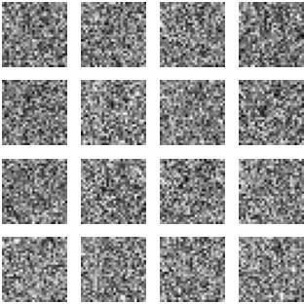

2/2 | [==============================] | - 0s | 5ms/step
2/2 | [==============================] | - 0s | 5ms/step
2/2 | [==============================] | - 0s | 7ms/step
2/2 | [==============================] | - 0s | 5ms/step
2/2 | [==============================] | - 0s | 5ms/step

2/2 [==============================] - 0s 8ms/step

2/2 [==============================] - 0s 6ms/step

2/2 [==============================] - 0s 5ms/step
2/2 [==============================] - 0s 5ms/step

Result
Thus the Implementing a simple generative adversial network is successfully completed.

Task 6

RECURRENT NEURAL NETWORKS

AIM:

To create and perform a recurrent neural networks PROCEDURE:
Step1: Import all necessary libraries Step2: Import keras model for processing Step3: Define Corpus and Tokenize
Step4: Convert text to Sequences with same length

Step5: Prepare input and target data and build RNN model

Step6: print model Summary

Program:
import tensorflow as tf
from tensorflow.keras.models import Sequential
from tensorflow.keras.layers import Embedding, LSTM, Dense from tensorflow.keras.preprocessing.text import Tokenizer
from tensorflow.keras.preprocessing.sequence import pad_sequences # Sample corpus
corpus = [
'I enjoy playing football', 'Football is my favorite sport',
'I watch football matches regularly'
]# Tokenize the corpus tokenizer = Tokenizer()

tokenizer.fit_on_texts(corpus)
total_words = len(tokenizer.word_index) + 1 # Convert text to sequences
sequences = tokenizer.texts_to_sequences(corpus) # Pad sequences to have the same length
max_sequence_length = max([len(seq) for seq in sequences])
padded_sequences = pad_sequences(sequences, maxlen=max_sequence_length, padding='post') # Prepare input and target data
input_data = padded_sequences[:, :-1] target_data = padded_sequences[:, -1] # Build the RNN model embedding_dim = 10
model = Sequential()
model.add(Embedding(total_words, embedding_dim, input_length=max_sequence_length-1)) model.add(LSTM(50))
model.add(Dense(total_words, activation='softmax')) model.summary()
# Compile the model
model.compile(loss='sparse_categorical_crossentropy', optimizer='adam', metrics=['accuracy']) # Train the model
model.fit(input_data, target_data, epochs=100, verbose=1) # Get the word embeddings
word_embeddings = model.layers[0].get_weights()[0] # Print word embeddings
for word, index in tokenizer.word_index.items():
embedding_vector = word_embeddings[index] print(f"{word}: {embedding_vector}") OUTPUT:
Epoch 1/100
1/1 [==============================] - 2s 2s/step - loss: 2.4875 - accuracy: 0.0000e+00
Epoch 2/100
1/1 [==============================] - 0s 17ms/step - loss: 2.4826 - accuracy: 0.0000e+00
Epoch 3/100
1/1 [==============================] - 0s 13ms/step - loss: 2.4776 - accuracy: 0.0000e+00

Epoch 4/100
1/1 [==============================] - 0s 13ms/step - loss: 2.4727 - accuracy: 0.3333
Epoch 95/100
1/1 [==============================] - 0s 16ms/step - loss: 0.7661 - accuracy: 1.0000
Epoch 96/100
1/1 [==============================] - 0s 16ms/step - loss: 0.7504 - accuracy: 1.0000
Epoch 97/100
1/1 [==============================] - 0s 16ms/step - loss: 0.7344 - accuracy: 1.0000
Epoch 98/100
1/1 [==============================] - 0s 20ms/step - loss: 0.7179 - accuracy: 1.0000
Epoch 99/100
1/1 [==============================] - 0s 16ms/step - loss: 0.7010 - accuracy: 1.0000
Epoch 100/100
1/1 [==============================] - 0s 15ms/step - loss: 0.6838 - accuracy: 1.0000

Result:
Thus, the Creating & performing recurrent neural network is sucessfully completed.
TASK 7 AUTO ENCODES
AIM:

To create a auto encodes by using keras model. PROCEDURE:
Step1: Import all libraries from keras Step 2: Initialize encoding dimension Step3: Give input image & encode
Step4: Load the dataset from google drive Step5: Train the dataset
Step6: Summarize the model

Program:
# -*- coding: utf-8 -*- """Autoencoder
Automatically generated by Colaboratory.

Original file is located at https://colab.research.google.com/drive/1J678VYoIlJT7kfn9SbQNdBdnSTdS06_I
"""
from keras.models import Model from keras.layers import Input, Dense from keras.datasets import mnist import numpy as np
import matplotlib.pyplot as plt encoding_dim = 64
input_img = Input(shape=(784,))
encoded = Dense(encoding_dim, activation='relu')(input_img) decoded = Dense(784, activation='sigmoid')(encoded) autoencoder = Model(input_img, decoded)
encoder = Model(input_img, encoded) encoded_input = Input(shape=(encoding_dim,)) decoder_layer = autoencoder.layers[-1]
decoder = Model(encoded_input,decoder_layer(encoded_input)) autoencoder.compile(optimizer='adadelta',loss='binary_crossentropy') (x_train, _),(x_test, _) = mnist.load_data()
x_train = x_train.astype('float32')/255 x_test = x_test.astype('float32')/255
x_train = x_train.reshape((len(x_train), (np.prod(x_train.shape[1:])))) x_test = x_test.reshape((len(x_test), (np.prod(x_test.shape[1:])))) print(f'x_train shape = {x_train.shape}')
print(f'x_test shape = {x_test.shape}')
autoencoder.fit(x_train, x_train, epochs=5, batch_size=32, shuffle=True, validation_data=(x_test, x_test))
encoded_imgs = encoder.predict(x_test) decoded_imgs = decoder.predict(encoded_imgs)
n = 10
plt.figure(figsize=(20,4)) for i in range(n):
ax = plt.subplot(2, n, i+1) plt.imshow(x_test[i].reshape(28, 28)) plt.gray()

ax.get_xaxis().set_visible(False) ax.get_yaxis().set_visible(False) ax = plt.subplot(2, n, i+1+n)
plt.imshow(decoded_imgs[i].reshape(28,28)) plt.gray()
ax.get_xaxis().set_visible(False) ax.get_yaxis().set_visible(False)
plt.show()
from google.colab import drive drive.mount('/content/drive')

OUTPUT:
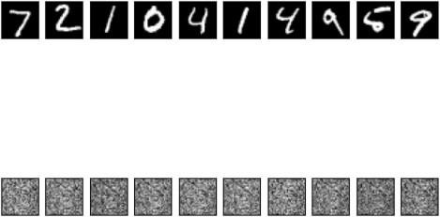

Result:
Thus Creating a autoencodes by using keras modelis sucessfully completed.

Task 8

LONG SHORT-TERM MEMORY

AIM:

To create a long short term memory(LSTM) classification model. PROCEDURE:
Step1: Import all libraries from keras Step2: Import the dataframe with a path Step3: locate the dataset in drive
Step4: Train the dataset

Step5: Summarize the model.

Program:
# -*- coding: utf-8 -*- """LSTM.ipynb
Automatically generated by Colaboratory.
Original file is located at
https://colab.research.google.com/drive/19SKdhO8GsH-bNjjdExu1AFMfA5MjNZ93 """
import pandas as pd import numpy as np
import matplotlib.pyplot as plt from google.colab import drive drive.mount('/content/drive')
df = pd.read_csv('/content/drive/MyDrive/monthlyMilkProduction.csv',index_col='Date',parse_dates=True
)

df.index.freq='MS' df.head() df.plot(figsize=(10,6))
from statsmodels.tsa.seasonal import seasonal_decompose results = seasonal_decompose(df['Production']) results.plot()
len(df)
train = df.iloc[:156] test = df.iloc[156:]
from sklearn.preprocessing import MinMaxScaler scaler = MinMaxScaler()
df.head(),df.tail() scaler.fit(train)
scaled_train = scaler.transform(train) scaled_test = scaler.transform(test) scaled_train[:10]
from keras.preprocessing.sequence import TimeseriesGenerator n_input = 3
n_features = 1

generator = TimeseriesGenerator(scaled_train, scaled_train, length=n_input, batch_size=1) print(len(scaled_train),len(generator))
from numpy.random.mtrand import f x,y = generator[0]
print(f'Given the Array: \n{x.flatten}') print(f'Predict this y: \n {y}')
x.shape n_input = 12
generator = TimeseriesGenerator(scaled_train, scaled_train, length=n_input, batch_size=1) from keras.models import Sequential
from keras.layers import Dense from keras.layers import LSTM model =Sequential()
model.add(LSTM(100, activation='relu', input_shape=(n_input, n_features))) model.add(Dense(1))
model.compile(optimizer='adam', loss='mse') model.summary()
model.fit(generator, epochs=50) loss_per_epoch = model.history.history['loss']
plt.plot(range(len(loss_per_epoch)),loss_per_epoch) last_train_batch = scaled_train[-12:]
last_train_batch = last_train_batch.reshape(1, n_input, n_features) model.predict(last_train_batch)
scaled_test[0] test_predictions = []
first_eval_batch = scaled_train[-n_input:]
current_batch = first_eval_batch.reshape((1, n_input, n_features)) for i in range(len(test)):
current_pred = model.predict(current_batch)[0] test_predictions.append(current_pred)
current_batch = np.append(current_batch[:,1:,:],[[current_pred]],axis=1) test_predictions
test.head()
true_predictions = scaler.inverse_transform(test_predictions) test['Predictions'] = true_predictions

test.plot(figsize=(10,6))
from sklearn.metrics import mean_squared_error from math import sqrt
rmse = sqrt(mean_squared_error(test['Production'],test['Predictions'])) print(rmse)

OUTPUT:
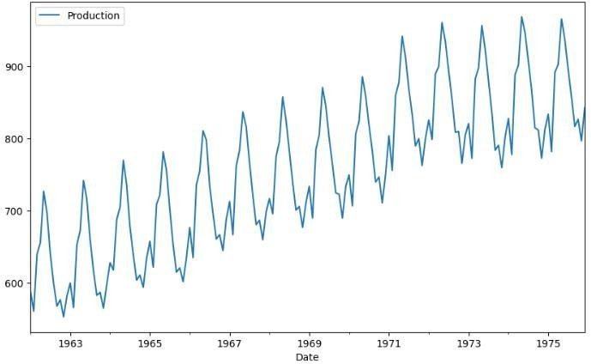

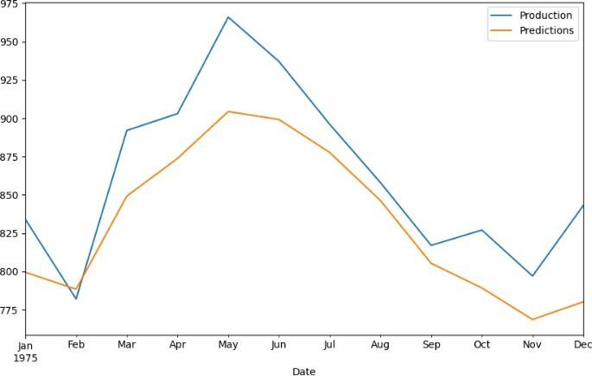

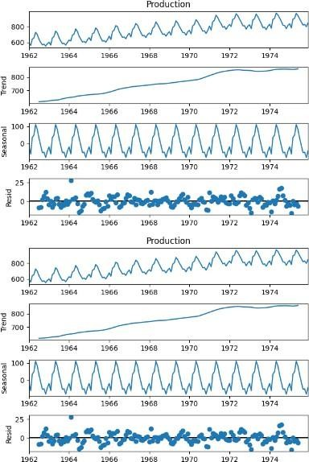

Epoch 1/50

144/144 [==============================] - 3s 8ms/step - loss: 0.0439

Epoch 2/50

144/144 [==============================] - 1s 8ms/step - loss: 0.0251

Epoch 3/50

144/144 [==============================] - 1s 7ms/step - loss: 0.0194

Epoch 4/50

144/144 [==============================] - 1s 8ms/step - loss: 0.0113
Epoch 5/50
144/144 [==============================] - 2s 11ms/step - loss: 0.0073

Epoch 6/50

144/144 [==============================] - 2s 13ms/step - loss: 0.0047

Epoch 7/50

144/144 [==============================] - 1s 9ms/step - loss: 0.0038

Epoch 8/50

144/144 [==============================] - 1s 8ms/step - loss: 0.0045

Epoch 9/50

144/144 [==============================] - 1s 8ms/step - loss: 0.0073

Epoch 10/50

144/144 [==============================] - 1s 9ms/step - loss: 0.0042
Epoch 11/50

144/144 [==============================] - 1s 9ms/step - loss: 0.0042

Epoch 12/50

144/144 [==============================] - 1s 8ms/step - loss: 0.0040

Epoch 13/50

144/144 [==============================] - 1s 8ms/step - loss: 0.0037

Epoch 14/50

144/144 [==============================] - 2s 11ms/step - loss: 0.0042

Epoch 15/50

144/144 [==============================] - 2s 13ms/step - loss: 0.0042

Epoch 16/50
144/144 [==============================] - 2s 14ms/step - loss: 0.0037
Epoch 17/50

144/144 [==============================] - 2s 12ms/step - loss: 0.0038

Epoch 18/50

144/144 [==============================] - 1s 8ms/step - loss: 0.0033

Epoch 19/50

144/144 [==============================] - 1s 8ms/step - loss: 0.0040

Epoch 20/50
144/144 [==============================] - 1s 9ms/step - loss: 0.0045
Epoch 21/50

144/144 [==============================] - 1s 9ms/step - loss: 0.0033

Epoch 22/50

144/144 [==============================] - 1s 9ms/step - loss: 0.0034

Epoch 23/50

144/144 [==============================] - 2s 13ms/step - loss: 0.0030

Epoch 24/50

144/144 [==============================] - 2s 12ms/step - loss: 0.0032

Epoch 25/50

144/144 [==============================] - 1s 9ms/step - loss: 0.0029

Epoch 26/50

144/144 [==============================] - 1s 7ms/step - loss: 0.0052
Epoch 27/50

144/144 [==============================] - 1s 7ms/step - loss: 0.0034

Epoch 28/50

144/144 [==============================] - 1s 9ms/step - loss: 0.0025

Epoch 29/50

144/144 [==============================] - 1s 7ms/step - loss: 0.0034

Epoch 30/50

144/144 [==============================] - 1s 7ms/step - loss: 0.0034

Epoch 31/50

144/144 [==============================] - 1s 8ms/step - loss: 0.0025
Epoch 32/50
144/144 [==============================] - 2s 13ms/step - loss: 0.0027

Epoch 33/50

144/144 [==============================] - 2s 11ms/step - loss: 0.0028

Epoch 34/50

144/144 [==============================] - 1s 9ms/step - loss: 0.0025

Epoch 35/50

144/144 [==============================] - 1s 8ms/step - loss: 0.0031

Epoch 36/50

144/144 [==============================] - 1s 10ms/step - loss: 0.0025

Epoch 37/50

144/144 [==============================] - 1s 8ms/step - loss: 0.0023
Epoch 38/50
144/144 [==============================] - 1s 8ms/step - loss: 0.0028

Epoch 39/50

144/144 [==============================] - 2s 11ms/step - loss: 0.0031

Epoch 40/50

144/144 [==============================] - 2s 13ms/step - loss: 0.0029

Epoch 41/50

144/144 [==============================] - 1s 9ms/step - loss: 0.0027

Epoch 42/50

144/144 [==============================] - 1s 9ms/step - loss: 0.0029

Epoch 43/50
144/144 [==============================] - 1s 8ms/step - loss: 0.0029
Epoch 44/50

144/144 [==============================] - 1s 7ms/step - loss: 0.0028

Epoch 45/50

144/144 [==============================] - 1s 8ms/step - loss: 0.0026

Epoch 46/50

144/144 [==============================] - 1s 8ms/step - loss: 0.0024

Epoch 47/50

144/144 [==============================] - 2s 11ms/step - loss: 0.0023

Epoch 48/50

144/144 [==============================] - 2s 13ms/step - loss: 0.0019

Epoch 49/50

144/144 [==============================] - 1s 9ms/step - loss: 0.0022

Epoch 50/50
144/144 [==============================] - 1s 8ms/step - loss: 0.0021
1/1 [==============================] - 0s 241ms/step array([0.67548077])

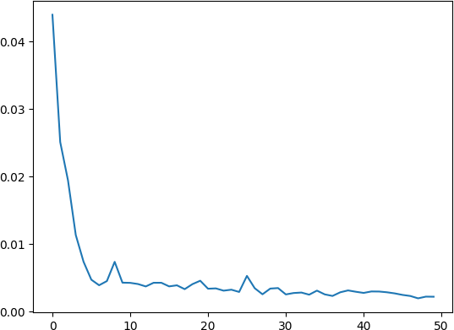

Result:
Thus the Creating a long short term classification model is successfully completed.

Task 9 CLASSIFICATION WITH LOCALIZATION
AIM:

To create & perform classification with localization PROCEDURE:
Step1: Downloading the detection dataset

Step2: perform data aquisition with image library Step3: Preprocess the dataset
Step4: Visualize the data with it annotations Step5: Split the data into train the model Step6: Compile & train the model
Step7: Plot model loss & accuracy curves

Program:
!pip install ultralytics import numpy as np

import os import cv2 import time
from ultralytics import YOLO # define some parameters CONFIDENCE = 0.5
font_scale = 1
thickness = 1
# loading the YOLOv8 model with the default weight file model = YOLO("yolov8n.pt")
# loading all the class labels (objects)
labels = open("/content/coco.names").read().strip().split("\n") # generating colors for each object for later plotting
colors = np.random.randint(0, 255, size=(len(labels), 3), dtype="uint8") path_name = "/content/dog.jpg"
image = cv2.imread(path_name)
file_name = os.path.basename(path_name) # "dog.jpg" filename, ext = file_name.split(".") # "dog", "jpg"
# measure how much it took in seconds start = time.perf_counter()
# run inference on the image
# see: https://docs.ultralytics.com/modes/predict/#arguments for full list of arguments results = model.predict(image, conf=CONFIDENCE)[0]
time_took = time.perf_counter() - start print(f"Time took: {time_took:.2f}s") print(results.boxes.data)
# loop over the detections
for data in results.boxes.data.tolist():
# get the bounding box coordinates, confidence, and class id

xmin, ymin, xmax, ymax, confidence, class_id = data
# converting the coordinates and the class id to integers xmin = int(xmin)
ymin = int(ymin) xmax = int(xmax) ymax = int(ymax) class_id = int(class_id)
# draw a bounding box rectangle and label on the image for class_id in class_ids:
color = [int(c) for c in colors[class_id]]
cv2.rectangle(image, (xmin, ymin), (xmax, ymax), color=color, thickness=thickness) text = f"{labels[class_id]}: {confidence:.2f}"
# calculate text width & height to draw the transparent boxes as background of the text
(text_width, text_height) = cv2.getTextSize(text, cv2.FONT_HERSHEY_SIMPLEX, fontScale=font_scale, thickness=thickness)[0]
text_offset_x = xmin text_offset_y = ymin - 5
box_coords = ((text_offset_x, text_offset_y), (text_offset_x + text_width + 2, text_offset_y - text_height))
overlay = image.copy()
cv2.rectangle(overlay, box_coords[0], box_coords[1], color=color, thickness=cv2.FILLED) # add opacity (transparency to the box)
image = cv2.addWeighted(overlay, 0.6, image, 0.4, 0) # now put the text (label: confidence %)
cv2.putText(image, text, (xmin, ymin - 5), cv2.FONT_HERSHEY_SIMPLEX, fontScale=font_scale, color=(0, 0, 0), thickness=thickness)
import cv2
from google.colab.patches import cv2_imshow # display output image
cv2_imshow(image) cv2.waitKey(0)
# save output image to disk cv2.imwrite(filename + "_yolo8." + ext, image)

OUTPUT:
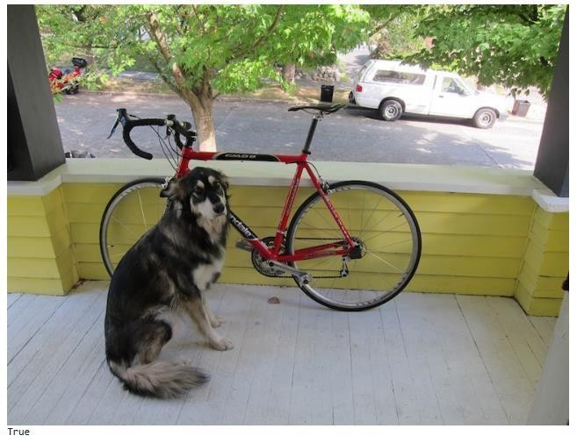

Result:
Thus, the Creating & performing classification with localization is successfully completed.

TASK 10 OPTIMIZERS
AIM:

To create & perform optimization by using tensorflow PROCEDURE:
Step 1: Import all libraries

Step2: Define points on x-axis & y-axis

Step3: Create a mesh of point of whih to evaluate the function Step4: Generate 20 levels on a log scale
Step5: Add a marker to show the minimum Step6: Change fontsize & plot f(r)
Step7: Plot all lines & vectors Step 8: Reset to initial fontsize

Step9: Execute

Step 10: Summarize the model # -*- coding: utf-8 -*- """Untitled10.ipynb
Automatically generated by Colaboratory.
Original file is located at https://colab.research.google.com/drive/1w7xl7q4u8bQ9dOo7vh98b3iB9POgt7Gn
"""
# Commented out IPython magic to ensure Python compatibility. # Commented out IPython magic to ensure Python compatibility.
!pip install tensorflow-gpu==2.0.0-beta0 > /dev/null 2>&1 import tensorflow as tf
import numpy as np
import matplotlib.pyplot as plt
from mpl_toolkits.mplot3d import Axes3D from IPython import display
# %matplotlib inline display.clear_output()
print("TensorFlow executing eagerly: {}".format(tf.executing_eagerly())) import tensorflow as tf
import numpy as np
import matplotlib.pyplot as plt
def rosenbrock_banana(x, y, a=1., b=20.):
return tf.math.pow(a - x, 2.) + b * tf.math.pow(y - tf.math.pow(x, 2.), 2.)
def gen_2d_loss_surface(loss_func, n_x=100, n_y=100, min_x=-2., max_x=2., min_y=-0.2, max_y=1.3):
x_vals = np.linspace(min_x, max_x, n_x) y_vals = np.linspace(min_y, max_y, n_y) X, Y = np.meshgrid(x_vals, y_vals)
Z = loss_func(X, Y) return X, Y, Z
# Usage example:

X, Y, Z = gen_2d_loss_surface(rosenbrock_banana) plt.contourf(X, Y, Z, levels=100, cmap='jet') plt.colorbar()
plt.xlabel('x')
plt.ylabel('y')
plt.title('Rosenbrock Banana Loss Surface') plt.show()
# create a mesh of points at which to evaluate our function X, Y = np.meshgrid(np.linspace(min_x, max_x, n_x),
np.linspace(min_y, max_y, n_y)) # evaluate the func at all of the points
Z = loss_func(X, Y).numpy() return X, Y, Z
def make_contour_plot(X, Y, Z, levels=None):
if levels == None:
# generate 20 levels on a log scale
levels = np.insert(np.logspace(0, 2.6, 20, True, base=10), 0, 0) fig = plt.figure(figsize=(9.84, 3))
ax = fig.gca()
ax.contour(X, Y, Z, levels, alpha=0.5) ax.contourf(X, Y, Z, levels, alpha=0.2) ax.set_xlabel('x')
ax.set_ylabel('y') return fig, ax
def make_surface_plot(X, Y, Z, elevation=0, azimuth_angle=0, levels=None): if levels == None:
# generate 20 levels on a log scale
levels = np.insert(np.logspace(0, 2.6, 20, True, base=10), 0, 0) fig = plt.figure(figsize=(10,6))
ax = fig.gca(projection='3d') ax.view_init(elevation, azimuth_angle)

ax.plot_surface(X, Y, Z, cmap='viridis', alpha=0.2) ax.contour(X, Y, Z, levels, cmap='viridis', alpha=0.5) ax.set_xlabel('x')
ax.set_ylabel('y') return fig, ax
X, Y, Z = gen_2d_loss_surface(rosenbrock_banana) fig, ax = make_contour_plot(X, Y, Z)
# add a marker to show the minimum ax.plot(1, 1, 'r*', ms=30, label='minimum') ax.legend()
fig.show() def f(x):
return -np.cos(x) def tangent_f(x):
return np.sin(x) def df(x, x_0):
return tangent_f(x_0) * (x - x_0) + f(x_0) def perpindicular_unit_f(x_0):
slope_f = tangent_f(x_0) y_0 = f(x_0)
x_1 = slope_f / np.sqrt(2) + x_0
y_1 = -x_1 / slope_f + y_0 + x_0 / slope_f return [[x_0, x_1], [y_0, y_1]]
def interactive_gradient_visual(x_0):
# change the fontsize for better visibility
init_size = plt.rcParams["font.size"] # store initial font size plt.rcParams.update({'font.size': 22}) # update the size plt.figure(figsize=(12, 8))
x = np.linspace(-np.pi, 2 * np.pi) f_x = f(x)
# plot f(x)

plt.plot(x, f_x, label=r"$f(x)$", color="green") # add a point showing where x_0 falls on f(x) plt.plot(x_0, f(x_0), marker="o", color="black") # plot the tangent line to f(x) at x_0
plt.plot(x, df(x, x_0), linestyle="--", color="cornflowerblue", label=r"$df(x)$") # plot the normal vector to the tangent
perp_unit_vector = perpindicular_unit_f(x_0) plt.plot(perp_unit_vector[0], perp_unit_vector[1], color="dimgray") # drop a vertical line from x_0
plt.plot([x_0, x_0], [f(x_0), -3.1], color="silver") # Usage example:
min_x, max_x = -3.1, 6.2
min_y, max_y = -3.1, 3.1
X, Y, Z = gen_2d_loss_surface(rosenbrock_banana, n_x=100, n_y=100, min_x=min_x, max_x=max_x, min_y=min_y, max_y=max_y)
plt.contourf(X, Y, Z, levels=100, cmap='jet')
# Define the perp_unit_vector (this is just an example; you need to calculate it based on your specific scenario)
perp_unit_vector = [[1.5, 2.5], [1.5, 1.5]] [[x_0, x_1], [y_0, y_1]] = perp_unit_vector dx = x_1 - x_0
dy = 0 # y_1 - y_1 arrow = plt.arrow( x_0, y_1, dx, dy,
color="red", label=r"$f'(x_0)$",
lw=3, head_width=np.abs(x_1 - x_0)/10, length_includes_head=True
)

plt.plot([x_0, x_1], [y_1, y_1], color="red", label=r"$f'(x_0)$") plt.legend(loc="upper left")
plt.xlim(min_x, max_x) plt.ylim(min_y, max_y) plt.xlabel(r"$x_0$")

plt.show()
# Add the following line to store and reset the initial font size init_size = plt.rcParams['font.size']
plt.show()
# Reset to the initial font size (you may skip this line if you don't want to reset it) plt.rcParams.update({'font.size': init_size})
interactive_gradient_visual(x_0) def f(x):
return -np.cos(x) def tangent_f(x):
return np.sin(x) def df(x, x_0):
return tangent_f(x_0) * (x - x_0) + f(x_0) def perpindicular_unit_f(x_0):
slope_f = tangent_f(x_0) y_0 = f(x_0)
x_1 = slope_f / np.sqrt(2) + x_0
y_1 = -x_1 / slope_f + y_0 + x_0 / slope_f return [[x_0, x_1], [y_0, y_1]]
def noisy_df(x, x_0, noisy_x_0):
return tangent_f(noisy_x_0) * (x - x_0) + f(x_0) def noisy_perpindicular_unit_f(x_0, noisy_x_0): slope_f = tangent_f(noisy_x_0)
y_0 = f(x_0)
x_1 = slope_f / np.sqrt(2) + x_0
y_1 = -x_1 / slope_f + y_0 + x_0 / slope_f return [[x_0, x_1], [y_0, y_1]]
def interactive_noisy_gradient_visual(x_0, noisy_x_0): # change the fontsize for better visibility
init_size = plt.rcParams["font.size"] # store initial font size plt.rcParams.update({'font.size': 22}) # update the size

plt.figure(figsize=(12, 8))
x = np.linspace(-np.pi, 2 * np.pi) f_x = f(x)
y_0 = f(x_0) # plot f(x)
plt.plot(x, f_x, label=r"$f(x)$", color="green") # add a point showing where x_0 falls on f(x) plt.plot(x_0, f(x_0), marker="o", color="black") # plot the tangent line to f(x) at x_0
plt.plot(x, df(x, x_0), linestyle="--", color="cornflowerblue", label=r"$df(x)$") # drop a vertical line from x_0
plt.plot([x_0, x_0], [f(x_0), -3.1], color="silver") # plot the noisy tangent line to f(x) at x_0
plt.plot(x, noisy_df(x, x_0, noisy_x_0), linestyle="--", color="red", label=r"$\widetilde{df}(x)$") # plot the normal vector to the tangent
[[x_0, x_1], [y_0, y_1]] = perpindicular_unit_f(x_0) plt.plot([x_0, x_1], [y_0, y_1], color="dimgray")
# Plot the noisy positive direction of the change vector dx = x_1 - x_0
dy = 0
arrow = plt.arrow( x_0, y_1, dx, dy,
color="red", label=r"$f'(x_0)$",
lw=3, head_width=np.abs(x_1 - x_0)/10, length_includes_head=True
)

plt.plot([x_0, x_1], [y_1, y_1], color="red", label=r"$\widetilde{f'}(x_0)$") plt.legend(loc="upper left")
plt.xlim(min_x, max_x) plt.ylim(min_y, max_y) plt.xlabel(r"$x_0$") plt.show()

# reset to initial font size plt.rcParams.update({'font.size': init_size})
def interactive_batch_size_visual(x_0, batch_size): np.random.seed(0)
noisy_x_0 = x_0 + np.mean(np.random.normal(loc=0, scale=0.5, size=batch_size)) interactive_noisy_gradient_visual(x_0, noisy_x_0)
x_0 = 2.7
batch_size = 20 interactive_batch_size_visual(x_0, batch_size)
def SGD_update(params, grads, states, hyper_params): # hyper-param typical values: learning_rate=0.01
# SGD doesn't have any state, however, the algorithms # we will look at later do!
for param, grad in zip(params, grads): param.assign_sub(hyper_params['lr'] * grad)
def optimize_banana(update_func, params, states, hyper_params): # plot the loss surface, minimum value and starting point
X, Y, Z = gen_2d_loss_surface(rosenbrock_banana) fig, ax = make_contour_plot(X, Y, Z)
ax.plot(1, 1, 'r*', ms=30, label='minimum') ax.plot(start_x, start_y, 'b*', ms=20, label='start') for epoch in range(epochs):
with tf.GradientTape() as tape:
# we are trying to minimize the output of the  func loss = rosenbrock_banana(x, y)
# calculate the gradients of the loss with respect to the params grads = tape.gradient(loss, params)
# save the old x and y values for the plot old_x = params[0].numpy()
old_y = params[1].numpy()
# update the parameters using SGD

update_func(params, grads, states, hyper_params) # plot the change in x and y for each update step ax.annotate('', xy=(x.numpy(), y.numpy()),
xytext=(old_x, old_y), arrowprops={'arrowstyle': '->', 'color': 'k', 'lw': 1},
va='center', ha='center')
ax.plot(x.numpy(), y.numpy(), 'g*', ms=20, label='end') ax.legend()
fig.show() start_x = -1
start_y = 0.73334
learning_rate = 0.015
epochs = 150
x = tf.Variable(start_x, dtype='float32') y = tf.Variable(start_y, dtype='float32') params = [x, y]
states = []
hyper_params = {"lr": learning_rate} optimize_banana(SGD_update, params, states, hyper_params) OUTPUT:
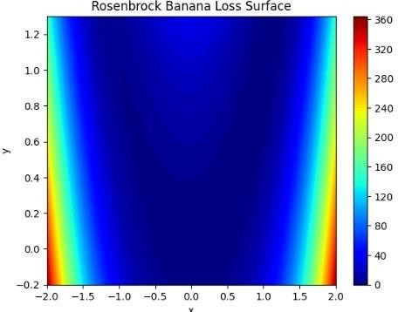

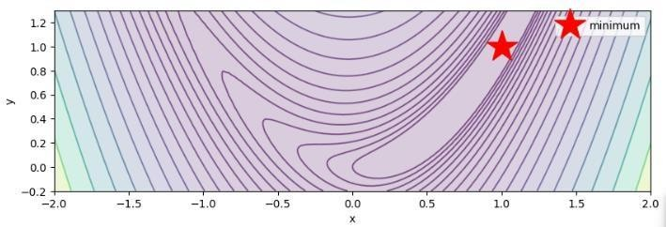

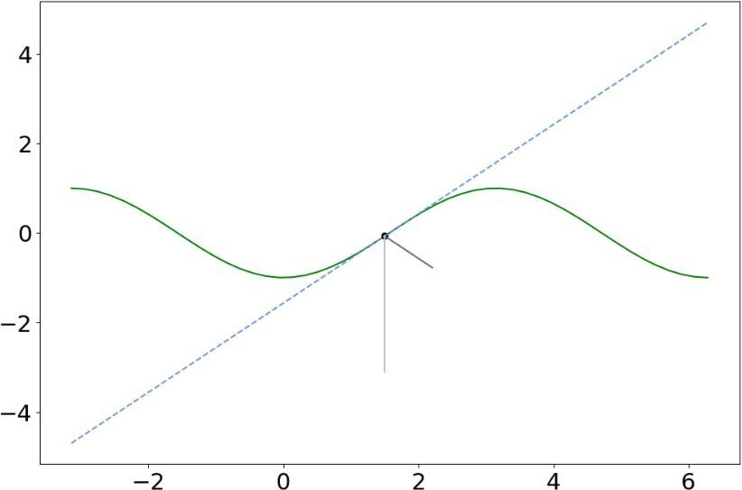

Result:
Thus the Creating & performing ptimization by using tensorflow successfully completed.

Task 10
Implement simple facts using python

Aim: To implement simple facts and verify using python

Algorithm:
Step:1Define a list of facts containing the statements to be verified.
Step:2 Create a function named verify_fact that takes a fact as input and returns a boolean value indicating whether the fact is true or false.
Step:3 In the verify_fact function:
- Remove the trailing period from the fact using the rstrip function.
- Check the fact against the known conditions to determine its truth value. You can use conditional statements (if, elif, else) for this.
  - If the fact matches a known condition, return True to indicate that the fact is true.
  - If the fact does not match any known condition, return False to indicate that the fact is false.
Step:4 Iterate over each fact in the list of facts:
- Call the verify_fact function for each fact.
- Print the fact and the corresponding "Yes" or "No" based on its truth value.

Program:
# Define a list of facts facts = [
"john_is_cold.", # john is cold "raining.", # it is raining
"john_Forgot_His_Raincoat.", # john forgot his raincoat "fred_lost_his_car_keys.", # fred lost his car keys "peter_footballer." # peter plays football
]

# Function to check if a fact is true def verify_fact(fact):
# Remove the trailing period fact = fact.rstrip(".")

# Perform some logic to verify the fact if fact == "john_Forgot_His_Raincoat":
return True
elif fact == "raining": return True
elif fact == "foggy": return True
elif fact == "Cloudy":
return False # Assume it's not cloudy else:
return False

# Verify each fact for fact in facts:
if verify_fact(fact): print(f"{fact} - Yes")
else:
print(f"{fact} - No")

Output:
john_is_cold. - No raining. - Yes
john_Forgot_His_Raincoat. - Yes fred_lost_his_car_keys. - No peter_footballer. – No

Result:
Thus the implementation of simple facts using python was successfully executed and output was verified.

